 

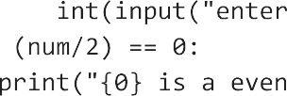

1. **Phyton**

Python is a general-purpose, interpreted, high-level programming language popularly used for website development, data analytics and automation.Python is a general-purpose language which means it is versatile and can be used to program many different types of functions



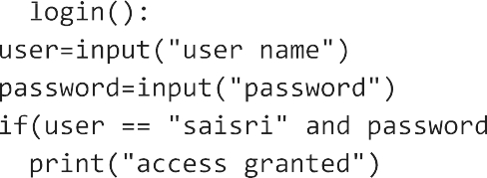

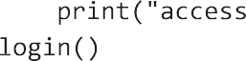



**3.**









 



**4.**





